Multiple Choice Questions

1) | In prokaryotes, _________ is used exclusively as the precursor for phosphatidic acid while in eukaryotes, _________is one of three possible precursors.

A) | diacylglycerol; glycerol-3-phosphate
B) | glycerol-3-phosphate; dihydroxyacetone phosphate
C) | dihydroxyacetone phosphate; glycerol-3-phosphate
D) | 3-phosphoglycerate; diacylglycerol
E) | dihydroxyacetone phosphate; diacylglycerol

Answer: B

Difficulty: 2 Topic: Metabolism of Glycerophospholipids

2) | Phospholipids are synthesized in the ___________, then transferred to the ____________ via transport vesicles.

A) | smooth endoplasmic reticulum; Golgi complex
B) | rough endoplasmic reticulum; smooth endoplasmic reticulum
C) | smooth endoplasmic reticulum; lysosome
D) | Golgi complex; smooth endoplasmic reticulum
E) | Golgi complex; cell membrane

Answer: A

Difficulty: Topic: Metabolism of Glycerophospholipids

3) | Which of the following phospholipids is produced in eukaryotes but not prokaryotes?

A) | phosphatidylglycerol
B) | phosphatidylserine
C) | phosphatidylethanolamine
D) | phosphatidylinositol
E) | none of the above

Answer: D

Difficulty: 2 Topic: Metabolism of Glycerophospholipids

4) | Which of the following is used to activate phosphatidic acid for conversion to various phospholipids?

A) | ATP
B) | UTP
C) | CTP
D) | GTP
E) | TTP

Answer: C

Difficulty: 1 Topic: Metabolism of Glycerophospholipids

5) | The biosynthesis of cardiolipin involves the reaction of phosphatidylglycerol with a molecule of ___________.

A) | phosphatidylglycerol
B) | phosphatidylserine
C) | phosphatidylethanolamine
D) | glycerol
E) | a fatty acyl-CoA

Answer: A

Difficulty: 2 Topic: Metabolism of Glycerophospholipids

6) | The synthesis of phosphatidylethanolamine in prokaryotes involves _________________ while in mammals _______________ occurs.

A) | reaction of CDP-diacylglycerol with ethanolamine; decarboxylation of phosphatidylserine
B) | decarboxylation of phosphatidylserine; reaction of CDP-ethanolamine with diacylglycerol
C) | reaction of phosphoethanolamine with diacylglycerol; reaction of CDP-ethanolamine with diacylglycerol
D) | decarboxylation of phosphatidylserine; reaction of CDP-diacylglycerol with ethanolamine
E) | reaction of CDP-diacylglycerol with ethanolamine; reaction of phosphoethanolamine with diacylglycerol

Answer: B

Difficulty: 3 Topic: Metabolism of Glycerophospholipids
7) | Which of the following amino acids is critical for choline and phosphatidylcholine synthesis?

A) | serine
B) | β-alanine
C) | homocysteine
D) | methionine
E) | homoserine

Answer: D

Difficulty: 2 Topic: Metabolism of Glycerophospholipids

8) | What is the term for the molecule shown below?
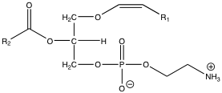
A) | platelet-activating factor
B) | 1-alkyl-2-acetylglcerophosphoethanolamine
C) | serine plasmologen
D) | choline plasmologen
E) | ethanolamine plasmologen

Answer: E

Difficulty: 2 Topic: Metabolism of Glycerophospholipids

9) | The synthesis of the glycosphingolipids begins with the reaction of either UDP-glucose or UDP-galactose with _____________.

A) | ceramide
B) | sphinganine
C) | sphingosine
D) | sphingomyelin
E) | none of the above

Answer: A

Difficulty: 1 Topic: Metabolism of Sphingolipids

10) | Tay-Sachs disease is caused by a deficiency of __________ which results in an accumulation of ___________.

A) | sphingomyelinase; sphingomyelin
B) | ceramidase; ceramide
C) | α-galactosidase A; GM₁ ganglioside
D) | lysosomal N-acetylhexosaminidase A; GM₂ ganglioside
E) | β-glucosidase; glucosylceramide

Answer: D

Difficulty: 2 Topic: Metabolism of Sphingolipids

11) | Which of the following is the regulatory step in cholesterol synthesis?

A) | HMG-CoA synthase
B) | HMG-CoA lyase
C) | HMG-CoA reductase
D) | squalene synthase
E) | squalene epoxidase

Answer: C

Difficulty: 2 Topic: Steroid Metabolism

12) | The synthesis of 1 molecule of cholesterol requires _____ molecules of isopentenyl pyrophosphate, with each molecule of isopentenyl pyrophosphate requiring _____ molecules of acetyl-CoA.

A) | 4; 2
B) | 5; 2
C) | 6; 2
D) | 5; 3
E) | 6; 3

Answer: E

Difficulty: 2 Topic: Steroid Metabolism

13) | Which of the following correctly identifies the order of carbocations found in the mechanism of squalene synthase?

A) | tertiary carbocation; allylic carbocation; tertiary cyclopropylcarbinyl carbocation
B) | tertiary carbocation; tertiary cyclopropylcarbinyl carbocation; allylic carbocation
C) | allylic carbocation; tertiary cyclopropylcarbinyl carbocation; tertiary carbocation
D) | allylic carbocation; tertiary carbocation; tertiary cyclopropylcarbinyl carbocation
E) | tertiary cyclopropylcarbinyl carbocation ; allylic carbocation; tertiary carbocation

Answer: D

Difficulty: 3 Topic: Steroid Metabolism

14) | Squalene epoxidase is an example of a mixed function oxidase, meaning that it uses both _______ and _______ as substrates.

A) | ATP; NADPH
B) | ATP; O₂
C) | NAD⁺; NADPH
D) | O₂; NAD⁺
E) | O₂; NADPH

Answer: E

Difficulty: 2 Topic: Steroid Metabolism

15) | How is the activity of HMG-CoA reductase reduced?

A) | allosteric inhibition by cholesterol
B) | ubiquitination in response to sterol accumulation resulting in proteolysis
C) | serine phosphorylation by an insulin-activated protein kinase
D) | tyrosine phosphorylation by AMPK
E) | none of the above

Answer: B

Difficulty: 2 Topic: Steroid Metabolism

16) | Which of the following explains why the bile acids are much better suited than cholesterol for use as emulsification agents for fats?

A) | cholesterol is oxidized to form the more polar molecule 7-hydroxycholesterol in route to formation of the bile acids
B) | while cholesterol contains a hydroxyl group as its sole hydrophilic functionality, cholic acid contains 3 hydroxyl groups and a carboxylic acid
C) | cholate is conjugated with glycine to make glycocholate
D) | cholate is conjugated with taurine to make taurocholate
E) | all of the above

Answer: E

Difficulty: 2 Topic: Steroid Metabolism

17) | Which of the following is accomplished in one enzyme catalyzed reaction?

A) | progesterone to androstenedione
B) | 17-hydroxyprogesterone to cortisol
C) | progesterone to aldosterone
D) | androstenedione to testosterone
E) | androstenedione to estradiol

Answer: D

Difficulty: 3 Topic: Steroid Metabolism

18) | Which of the following forms of vitamin A is covalently attached to a lysine residue of the protein opsin to form the complex called rhodopsin?

A) | all-trans-retinal
B) | 11-cis-retinal
C) | all-trans-retinoic acid
D) | all-trans-retinol
E) | β-carotene

Answer: B

Difficulty: 1 Topic: Other Isoprenoid Compounds

19) | 7-dehydrocholesterol reacts with _________ to produce cholecalciferol (vitamin D₃)

A) | UV light
B) | visible light
C) | NADPH
D) | NAD⁺
E) | none of the above

Answer: A

Difficulty: 1 Topic: Other Isoprenoid Compounds

20) | The enzyme PGH synthase contains two different functionalities, a __________ that uses two molecules of oxygen as substrates and __________ which performs a 2 electron reduction.

A) | cyclooxygenase; peroxidase
B) | cyclooxygenase; reductase
C) | dioxygenase; peroxidase
D) | dioxygenase; reductase
E) | lipoxygenase; peroxidase

Answer: A

Difficulty: 2 Topic: Eicosanoids

21) | What classification is given to the following molecule?

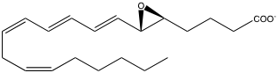

A) | a prostaglandin G derivative
B) | a prostaglandin E derivative
C) | a leukotriene
D) | a thromboxane
E) | none of the above

Answer: C

Difficulty: 1 Topic: Eicosanoids

22) | The synthesis of which of the following molecules would be inhibited by aspirin?

A) | prostaglandin F_{2α}
B) | prostaglandin D₂
C) | prostaglandin E₂
D) | prostaglandin H₂
E) | all of the above

Answer: E

Difficulty: 1 Topic: Eicosanoids

Short Answer Questions

1) Show the products of the following reaction and name them:

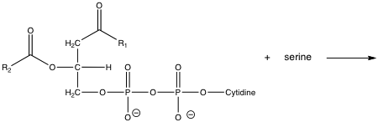

Answer:

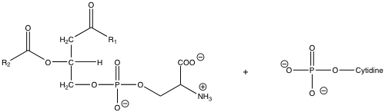
phosphatidylserine cytidine monophosphate (CMP)

Difficulty: 2 Topic: Metabolism of Glycerophospholipids

2) In eukaryotes, the conversion of DHAP to 1-acylglycerol-3-phosphate is a two-step process. Show the reactants and products missing in the following scheme.

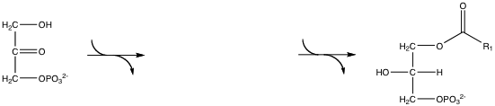

Answer:

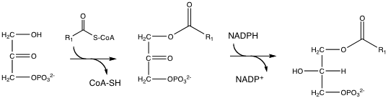

Difficulty: 3 Topic: Metabolism of Glycerophospholipids

3) Show the reaction catalyzed by 3-hydroxy-3-methylglutrayl-CoA reductase.

Answer:

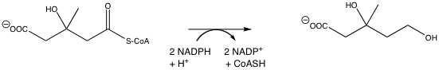

Difficulty: 2 Topic: Steroid Metabolism

